**ICS 2103 - INTRODUCTION TO SYSTEMS PROGRAMMING.**

**ASSIGNMENT.**

1. The program crashes at line 19. This happens because of an unexpected infinity, there is some expression attempting to divide a number by zero. In this case, when the for loop is declared, i is initialized to zero and d1 and d2 are both expressions that attempt to divide n by zero. Therefore in the first loop the program crashes since i has a value of zero.

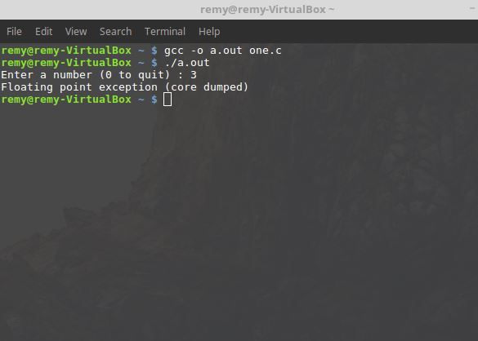

1. A compile time error is a problem that prevents a program from being successfully converted from source code into machine code. It is produced by the compiler and may be a syntax error or a missing file reference. A runtime error is a bug that occurs while the program is running after it has been compiled into an executable program. Examples include features that do not work or when a program crashes.
2. The problem is a program design flaw.

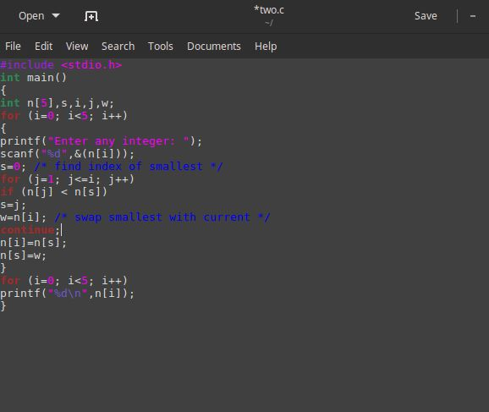

1. To make use of a library, one must:

First, include the header file for the library. The header file does not contain the code for any of the functions but instead is the instructions on how to use the library. For example, if we were using the math library then we would include the header file math.h as follows;

#include <math.h>

Secondly, one must link to the library while compiling. This involves bringing in the library file which contains actual code for the functions in the library. For example;

gcc -o sq sq.c -lm /*This tells the compiler to link (-l) to a library file named m- the math library. */

1. The memory map is as follows:

0th or the front set of numbers

|  |  |  |  |  |  |
| --- | --- | --- | --- | --- | --- |
| Label | i | i | i | i | i |
| Value | 0 | 0 | 0 | 0 | 3 |
| Address | 200 | 204 | 208 | 212 | 216 |

1st or the middle set of numbers

|  |  |  |  |  |  |
| --- | --- | --- | --- | --- | --- |
| Label | j | j | j | j | j |
| Value | 0 | 0 | 3 | 6 | 0 |
| Address | 220 | 224 | 228 | 232 | 236 |

2nd or the last set of numbers

|  |  |  |  |  |  |
| --- | --- | --- | --- | --- | --- |
| Label | k | k | k | k | k |
| Value | 4196125 | 3 | 0 | 0 | 0 |
| Address | 240 | 244 | 248 | 252 | 256 |

1. A system call is a set of functions provided by the Operating System kernel to enable it to act as a moderator between applications and resources of the computer.

System calls are used to request access to the resources of the machine, to communicate with other currently running programs, and to start new programs.

1. The output from the program is:

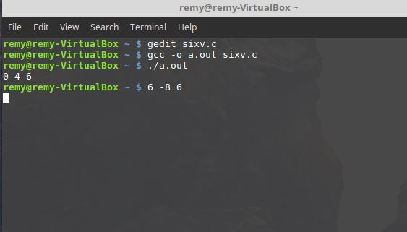

Memory map for the parent process:

|  |  |  |
| --- | --- | --- |
| Label | Value | Address |
| i | 0 | 100 |
| j | 4 | 104 |
| k | 6 | 108 |

Memory map for the child process:

|  |  |  |
| --- | --- | --- |
| Label | Value | Address |
| i | 6 | 112 |
| j | -8 | 116 |
| k | 6 | 120 |